

**Name:** Manvendra Gosain

**Registration Number:** 22MCA0321

1. Demonstrate how to register a variable using session and how to link correctly to another page using SID.

**index.php:**

<?php

session_start();

if ($_SERVER["REQUEST_METHOD"] === "POST" && isset($_POST['username'])) {

    $_SESSION['username'] = htmlspecialchars($_POST['username']);

}

?>

<!DOCTYPE html>

<html>

<head>

    <title>22MCA0321 | Page 1</title>

</head>

<body>

    <h1>Welcome to the Main Page</h1>

    <form method="post">

        <label for="username">Enter your username:</label>

        <input type="text" name="username" id="username" required>

        <input type="submit" value="Submit">

    </form>

    <?php if (isset($_SESSION['username'])) : ?>

        <a href="next_page.php?<?php echo htmlspecialchars(SID); ?>">Go to next page</a>

    <?php endif; ?>

</body>

</html>

**next_page.php:**

<?php

session_start();

?>

<!DOCTYPE html>

<html>

<head>

    <title>22MCA0321 | Next Page</title>

</head>

<body>

    <h1>Welcome to the Next Page</h1>

    <p>Hello, <?php echo $_SESSION['username']; ?></p>

</body>

</html>

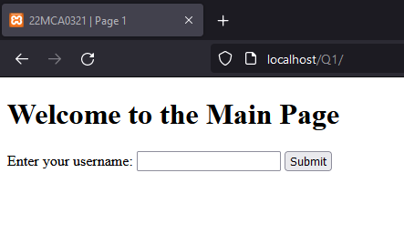

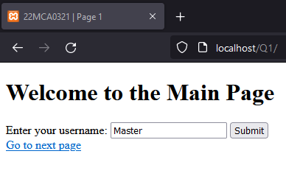



1. Write a PHP script to upload ‘Internet and Web Programming J Component File’ with the following constraints.

a. Student should upload either in .doc, .docx, pdf files only

b. Maximum file size is 10 MB

c. Prevent file duplication when a file is uploaded again.

<?php

**function** isValidFileExtension($fileName) {

        $allowedExtensions = array('doc', 'docx', 'pdf');

        $fileExtension = pathinfo($fileName, PATHINFO_EXTENSION);

        return in_array($fileExtension, $allowedExtensions);

    }

**function** isValidFileSize($fileSize, $maxSize) {

        return $fileSize <= $maxSize;

    }

**function** isFileAlreadyUploaded($fileName, $targetDirectory) {

        $filePath = $targetDirectory . $fileName;

        return file_exists($filePath);

    }

**function** showError($errorMessage) {

        echo "<p class='error-message'>$errorMessage</p>";

    }

**function** showSuccess($successMessage) {

        echo "<p class='success-message'>$successMessage</p>";

}

?>

<!DOCTYPE html>

<html>

<head>

    <title>22MCA0321 | File Upload</title>

    <style>

        body {

            font-family: Arial, sans-serif;

            text-align: center;

            background-color: #f9f9f9;

            padding: 50px;

        }

        h2 {

            color: #333;

            margin-bottom: 20px;

        }

        .upload-form {

            max-width: 300px;

            margin: 0 auto;

            background-color: #fff;

            padding: 20px;

            border: 1px solid #ccc;

            border-radius: 5px;

            box-shadow: 0 2px 5px rgba(0, 0, 0, 0.1);

        }

        .upload-form input[type="file"] {

            padding: 10px;

            margin-bottom: 10px;

            width: 100%;

        }

        .upload-form input[type="submit"] {

            background-color: #4CAF50;

            color: #fff;

            padding: 10px 20px;

            border: none;

            cursor: pointer;

            border-radius: 3px;

            width: 100%;

        }

        .upload-form input[type="submit"]:hover {

            background-color: #45a049;

        }

        .error-message {

            color: #f44336;

            margin-top: 10px;

        }

        .success-message {

            color: #4CAF50;

            margin-top: 10px;

        }

    </style>

</head>

<body>

    <div class="upload-form">

        <h2>Upload 'Internet and Web Programming J Component File'</h2>

        <form action="<?php echo htmlspecialchars($_SERVER["PHP_SELF"]); ?>" method="post" enctype="multipart/form-data">

            <input type="file" name="file" id="file">

            <input type="submit" name="submit" value="Upload">

        </form>

    </div>

    <div class="error-space">

        <?php

        if ($_SERVER["REQUEST_METHOD"] === "POST") {

            $targetDirectory = "uploads/";

            $maxFileSize = 10 * 1024 * 1024; *// 10 MB*

*// Check if a file was uploaded*

            if (isset($_FILES["file"]) && $_FILES["file"]["error"] === UPLOAD_ERR_OK) {

                $fileName = $_FILES["file"]["name"];

                $fileSize = $_FILES["file"]["size"];

                $fileTmpName = $_FILES["file"]["tmp_name"];

*// Validate file extension*

                if (!isValidFileExtension($fileName)) {

                    showError("Error: Invalid file extension. Only .doc, .docx, and .pdf files are allowed.");

                }

*// Validate file size*

                elseif (!isValidFileSize($fileSize, $maxFileSize)) {

                    showError("Error: File size exceeds the maximum limit of 10 MB.");

                }

*// Check if the file already exists*

                elseif (isFileAlreadyUploaded($fileName, $targetDirectory)) {

                    showError("Error: File with the same name already exists. Please upload a different file.");

                }

*// Move the uploaded file to the target directory*

                elseif (move_uploaded_file($fileTmpName, $targetDirectory . $fileName)) {

                    showSuccess("File uploaded successfully.");

                } else {

                    showError("Error uploading the file.");

                }

            } else {

                showError("Error: Please select a valid file.");

            }

        }

        ?>

    </div>

</body>

</html>

